KIRF: I can convert between decimals, fractions and percentages.
Children should be able to convert between fractions, decimals and percentages and recall common decimal, fraction and percentage equivalences instantly.

Concrete:  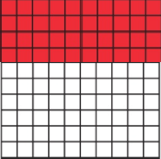  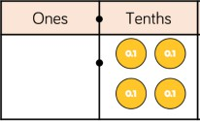  0.4 = ⁴ = 40%  10 | What can this look like?  Pictorial: Abstract:  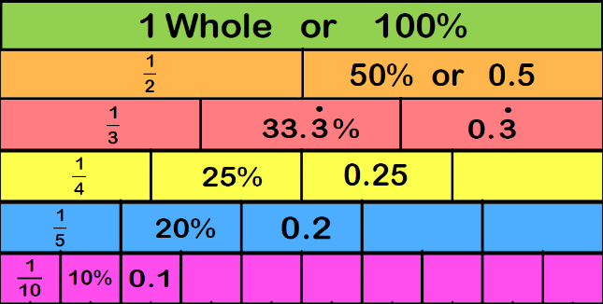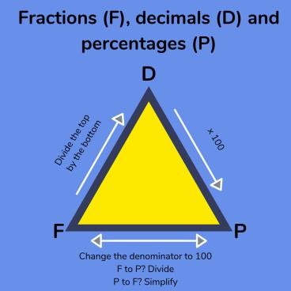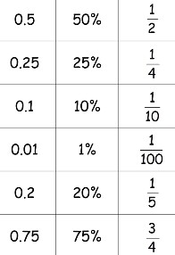
Questions to ask at home  What is 15% as a fraction and decimal?  Which is closer to 100%, ⁴ or 0.5? How do you  5  know?  Complete the sentence- to convert a decimal to a percentage you … | Things to try  Dominos- write the fraction, decimal and percentage the domino is showing  Pairs game- make your own fraction, decimal, percentage card matching game  FDP Poster- create a poster which explains how to convert between fractions, decimals and percentages  Let’s go shopping- look out for percentages when out shopping. What is 25% as a decimal?  Websites: https://www.mathplayground.com/percent04.html  https://mathsframe.co.uk/en/resources/resource/120/match_fractions_decimals_and_per centages#.UCdcd2MsCEY  https://whiterosemaths.com/homelearning/year-6/spring-week-3-number-percentages/
Key vocabulary
Convert- To change the expression without changing the size or amount.
Decimal number- A number with a decimal point.
Fraction- A fraction represents the equal parts of the whole.
Per cent- Parts per 100. It shows the ratio ‘out of 100’.
.
Key vocabulary
Array- An ordered collection of counters, cubes or other item in rows and columns. Common factors- A number that can be divided into two different numbers, without
leaving a remainder.
Factor- A number that multiplies with another to make a product.
Product- The result of multiplying one number
by another.
Year Six – Autumn 2

