Year Six – Autumn 1
KIRF: I can identify common factors of a pair of numbers.

Children should be able to use their knowledge of factors to find the common factors of two numbers.
What can this look like?
Concrete: Pictorial: Abstract:

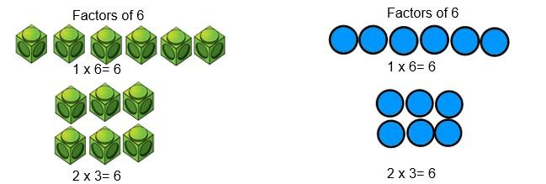  Concrete: | What can this look like?  Pictorial: Abstract:  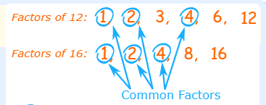
Questions to ask at home  What are the common factors of 18 and 21? Is 12 a common factor of 48 and 36?  What is the highest common factor of 12 and 24? | Things to try  Factor Rainbows- children can draw, paint or chalk factor rainbows.  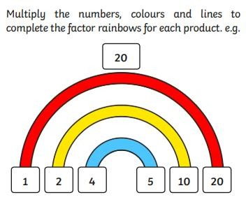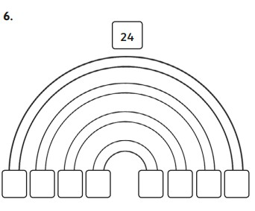  Websites:  https://www.topmarks.co.uk/maths-games/multiples-and-factors https://www.mathnook.com/math/math-speed-racing-factors.html https://www.math-play.com/Factors-Millionaire/factors-millionaire-game_html5.html  https://whiterosemaths.com/homelearning/year-5/week-8-number-multiplication-division/
Key vocabulary
Array- An ordered collection of counters, cubes or other item in rows and columns. Common factors- A number that can be divided into two different numbers, without
leaving a remainder.
Factor- A number that multiplies with another to make a product.
Product- The result of multiplying one number by another.

