 | ST JOSEPH’S CATHOLIC PRIMARY SCHOOL  ADMISSION POLICY 2028/2029 | 

St Joseph’s Catholic Primary School was founded by the Catholic Church to provide education for children of Catholic families. Whenever there are more applications than places available, priority will be given to Catholic children in accordance with the oversubscription criteria listed below. The school is conducted by its governing body as part of the Catholic Church in accordance with its trust deed and instrument of government, and seeks at all times to be a witness to Our Lord Jesus Christ.
As a Catholic school, we aim to provide a Catholic education for all our pupils. At a Catholic school, Catholic doctrine and practice permeate every aspect of the school’s activity. It is essential that the Catholic character of the school’s education be fully supported by all families in the school. We therefore hope that all parents will give their full, unreserved and positive support for the aims and ethos of the school. This does not affect the right of an applicant who is not Catholic to apply for and be admitted to a place at the school in accordance with these admission arrangements.
The governing body is the admission authority and has responsibility for admissions to this school. The local authority undertakes the co-ordination of admission arrangements during the normal admission round. The admission authority has set the school’s Published Admissions Number (“PAN”) at 30 pupils to be admitted to Reception in the school year which begins in September 2028.
The admission authority will, where logistically possible, admit twins and all siblings from multiple births where one of the children is the last child ranked within the school’s PAN.

Pupils with an Education, Health and Care Plan (see note 1)
The admission of pupils with an Education, Health and Care Plan is dealt with by a completely separate procedure. Children with an Education, Health and Care Plan that names the school must be admitted. Where this takes place before the allocation of places under these arrangements this will reduce the number of places available to other children.

Oversubscription Criteria
Where there are more applications for places than the number of places available, places will be offered according to the following order of priority.
- Catholic looked after and previously looked after children. (see notes 2 & 3)
- Catholic children who are resident in the former parishes of St Joseph’s Darlaston, St Mary’s, Willenhall within the St Newman parish boundary, (see notes 3 & 10)
- Catholic children who are resident in the former parishes of St Joseph’s, Wolverhampton and Holy Trinity, Bilston, within the St Newman parish boundary
- Other Catholic children. (see note 3)
- Other looked after and previously looked after children. (see note 2)
- Catechumens and members of an Eastern Christian Church. (see notes 4 & 5)
- Children of other Christian denominations whose membership is evidenced by a minister of religion. (see note 6)
- Children of other faiths whose membership is evidenced by a religious leader. (see note 7)
- Any other children.
Within each of the categories listed above, the following provisions will be applied in the following order.
- The attendance of a brother or sister at the school at the time of enrolment will increase the priority of an application within each category so that the application will be placed at the top of the category in which the application is made (see note 8).
- Distance as outlined in the Tie Break explanation below
Tie Break
Priority will be given to children living closest to the school determined by the shortest distance. Distance will be measured in a straight line from the centre point of the home address to the centre point of the school address using the Local Authority’s computerised measuring system with those living closer to the school receiving the higher priority. In the event of distances being the same for two or more children where this would determine the last place to be allocated, random allocation will be carried out and supervised by a person independent of the school. All the names will be entered into a hat and the required number of names will be drawn out.

Application Procedures and Timetable
To apply for a place at this school in the normal admission round, you must complete a Common Application Form available from the local authority in which you live. You are also requested to complete the Supplementary Information Form (SIF) if you wish to apply under oversubscription criteria 1 to 3 or 5 to 7. The Supplementary Information Form is available on the Local Authority’s website or a copy can be collected from the St Joseph’s school office and should be returned to Mr Hugh Carroll, Chair of Govenors, St Joseph’s Catholic Primary School, Rough Hay Road, Darlaston, WS10 8HN by 15th January 2028.
You will be advised of the outcome of your application on 16th April or the next working day, by the local authority on our behalf. If you are unsuccessful (unless your child gained a place at a school you ranked higher) you will be informed of the reasons, related to the oversubscription criteria listed above, and you have the right of appeal to an independent appeal panel.
If you do not provide the information required in the SIF and return it by the closing date, together with all supporting documentation, your child may not be placed in criteria 1 to 3 or 5 to 7, and this may affect your child’s chance of being offered a place.
All applications which are submitted on time will be considered at the same time and after the closing date for admissions which is 15th January 2028.
Late Applications and Change in Preferences
Late applications and change to school preferences listed on the Common Application Form will be administered in accordance with your home Local Authority Primary Co-ordinated Admissions Scheme. This can be viewed from the primary school admissions link on the local authority’s school admissions website at https://go.walsall.gov.uk/schools-and-learning/school-admissions
You are encouraged to ensure that your application is received on time.
Admission of Children Below Compulsory School Age and Deferred Entry
A child is entitled to a full-time place in the September following their fourth birthday. A child’s parents may defer the date at which their child, below compulsory school age, is admitted to the school, until later in the school year but not beyond the point at which they reach compulsory school age, or beyond the beginning of the final term of the school year for which an offer was made. A child may take up a part-time place until later in the school year, but not beyond the point at which the child reaches compulsory school age. Upon receipt of the offer of a place a parent should notify the school, as soon as possible, that they wish to either defer their child’s entry to the school or take up a part-time place.
Admission of Children outside their Normal Age Group
A request may be made for a child to be admitted outside of their normal age group, for example, if the child is gifted and talented or has experienced problems such as ill health. In addition, the parents of a summer born child, i.e. a child born between 1st April and 31st August, may request that the child be admitted out of their normal age group, to reception rather than year 1.
Any such request should be made in writing to Mr H Carroll, Chair of Govenors, St Joseph’s Catholic Primary School, Rough Hay Road, Darlaston, WS10 8HN at the same time as the admission application is made. The admission authority will make its decision about the request based on the circumstances of each case and in the best interests of the child. In addition to taking into account the views of the head teacher, including the head teacher’s statutory responsibility for the internal organisation, management and control of the school, the admission authority will take into account the views of the parents and of appropriate medical and education professionals, as appropriate.
Parents considering submitting a request for their child to be admitted to a class outside of their normal age group are recommended to read DfE guidance which can be found at https://www.gov.uk/government/publications/summer-born-children-school-admission/summer-born-children-starting-school-advice-for-parents
Waiting Lists
In addition to their right of appeal, unsuccessful children will either be automatically placed on a waiting list or given the opportunity to be placed on a waiting list (depending on how the local authority operates). This waiting list will be maintained in order of the oversubscription criteria set out above and not in the order in which applications are received or added to the list. Waiting lists for admission will operate throughout the school year. The waiting list will be held open until the last day of the summer term 2029 and will then be discarded.
Inclusion in the school’s waiting list does not mean that a place will eventually become available.
Children who are subject of a direction by the Local Authority or Secretary of State or who are allocated to a school in accordance with the Fair Access Protocol take precedence over any child on the waiting list.
In-Year Applications
An application can be made for a place for a child at any time outside the normal admission round and the child will be admitted where there are available places. Application should be made via the local authority. Further information on how to make an in-year application is available on our website at St Joseph's Catholic Primary School - Admissions
Where there are places available but more applications than places, the published oversubscription criteria, as set out above, will be applied.
If there are no places available, the child will be added to the waiting list (see above).
You will be advised of the outcome of your application in writing, and you have the right of appeal to an independent appeal panel.

Fair Access Protocol
The school is committed to taking its fair share of children who are vulnerable and/or hard to place, as set out in locally agreed protocols. Accordingly, outside the normal admission round the admission authority is empowered to give absolute priority to a child where admission is requested under any locally agreed protocol. The admission authority has this power, even when admitting the child would mean exceeding the PAN (subject to the infant class size exceptions).

Nursery
For children attending the school’s nursery, application to the reception class of the school must be made in the normal way, to the home local authority. Attendance at the school’s nursery does not automatically guarantee that a place will be offered at the school. Parents must apply for a Reception place in exactly the same way as parents of children not attending the Nursery. All applications will be considered against the oversubscription criteria by the admission authority in the same way regardless of whether the child does or does not attend the Nursery at the time of application.
Withdrawal
The admission authority reserves the right to withdraw the offer of a place or, where a child is already attending the school the place itself, where it is established that the offer or place was obtained through a fraudulent or intentionally misleading application.
Appeals
Parents who wish to appeal against the decision of the admission authority to refuse their child a place in the school should make that appeal request in writing to the Chair of Governors at the school address. Appeals will be heard by an independent panel.
Please note that parents do not have the right to appeal if their request for their child to be admitted to a class outside of their normal age group has been refused, but the admission authority has offered a place in the normal age group instead.
Further Applications and Further Appeals
Any parent can apply for a place for their child at any time outside of the normal admission round. Parents do not have the right to a second appeal in respect of the same school for the same academic year unless, in exceptional circumstances, the admission authority has accepted a second application from the parent because of a significant and material change in the circumstances of the parent, child or school but have still refused admission.

Notes
(these notes form part of the oversubscription criteria)
- An Education, Health and Care Plan is a plan made by the local authority under section 37 of the Children and Families Act 2014, specifying the special educational provision required for a child.
- A ‘looked after child’ has the same meaning as in section 22(1) of the Children Act 1989, and means any child who is (a) in the care of a local authority or (b) being provided with accommodation by them in the exercise of their social services functions (e.g. children with foster parents) at the time of making an application to the school.
A ‘previously looked after child’ is a child who was looked after, but ceased to be so because he or she was adopted, or became subject to a child arrangements order or special guardianship order. Included in this definition are those children who appear (to the admission authority) to have been in state care outside of England and who ceased to be in state care as a result of being adopted.
For the purposes of this policy, a looked after child living with a family where at least one of the parents/carers is Catholic will be considered as Catholic (see Appendix 1).
- ‘Catholic’ means a member of a Church in full communion with the See of Rome (See Appendix 1). This includes the Eastern Catholic Churches. This will normally be evidenced by a certificate of baptism in a Catholic Church or a certificate of reception into the full communion of the Catholic Church. For the purposes of this policy, it includes a looked after child living with a family where at least one of the parents is Catholic.
For a child to be treated as Catholic, evidence of Catholic baptism or reception into the Church will be required. Those who have difficulty obtaining written evidence of baptism should contact their Parish Priest who, after consulting with the Diocese, will decide how the question of baptism is to be resolved and how written evidence is to be produced in accordance with the law of the Church.
- ‘catechumen’ means a member of the catechumenate of a Catholic Church. This will normally be evidenced by a certificate of reception into the order of catechumens.
- ‘Eastern Christian Church’ includes Orthodox Churches, and is normally evidenced by a certificate of baptism or reception from the authorities of that Church.
- “children of other Christian denominations” means children who belong to other churches and ecclesial communities which, acknowledge God’s revelation in Christ, confess the Lord Jesus Christ as God and Saviour according to the Scriptures, and, in obedience to God’s will and in the power of the Holy Spirit commit themselves: to seek a deepening of their communion with Christ and with one another in the Church, which is His body; and to fulfil their mission to proclaim the Gospel by common witness and service in the world to the glory of the one God, Father, Son and Holy Spirit. An ecclesial community which on principle has no credal statements in its tradition, is included if it manifests faith in Christ as witnessed to in the Scriptures and is committed to working in the spirit of the above.
All members of Churches Together in England and CYTÛN are deemed to be included in the above definition, as are all other churches and ecclesial communities that are in membership of any local Churches Together Group (by whatever title) on the above basis.
- “children of other faiths” means children who are members of a religious community that does not fall within the definition of ‘other Christian denominations’ at 6 above and which falls within the definition of a religion for the purposes of charity law. The Charities Act 2011 defines religion to include:
- A religion which involves belief in more than one God, and
- A religion which does not involve belief in a God.
Case law has identified certain characteristics which describe the meaning of religion for the purposes of charity law, which are characterised by a belief in a supreme being and an expression of belief in that supreme being through worship.
- ‘brother or sister’ includes:
- all natural brothers or sisters, half brothers or sisters, adopted brothers or sisters, stepbrothers or sisters, foster brothers or sisters, whether or not they are living at the same address; and
- the child of a parent’s partner where that child lives for at least part of the week in the same family unit at the same home address as the child who is the subject of the application.
- A ‘parent’ means all natural and adoptive parents, any person who is not a parent but has parental responsibility for a child, and any person who has care of a child.
- For the purposes of this policy, parish boundaries are outlined in Appendix 2 and will be applied to the admission arrangements for 2028/2029.
- A child’s “home address” refers to the address where the child usually lives with a parent or carer, and will be the address provided in the Common Application Form (“CAF”). Where parents have shared responsibility for a child, and the child lives for part of the week with each parent, the home address will be the address given in the CAF, provided that the child resides at that address for any part of the school week. Parents may be requested to supply documentary evidence to satisfy the admission authority that the child lives at the address put forward by the parents.
Appendix 1

DEFINITION OF A “BAPTISED CATHOLIC”
A “Baptised Catholic” is one who:
- Has been baptised into full communion (Cf. Catechism of the Catholic Church, 837) with the Catholic Church by the Rites of Baptism of one of the various ritual Churches in communion with the See of Rome. Written evidence of this baptism can be obtained by recourse to the Baptismal Registers of the church in which the baptism took place (Cf. Code of Canon Law, 877 & 878).
Or
- Has been validly baptised in a separated ecclesial community and subsequently received into full communion with the Catholic Church by the Rite of Reception of Baptised Christians into the Full Communion of the Catholic Church. Written evidence of their baptism and reception into full communion with the Catholic Church can be obtained by recourse to the Register of Receptions, or in some cases, a sub-section of the Baptismal Registers of the church in which the Rite of Reception took place (Cf. Rite of Christian Initiation, 399).
WRITTEN EVIDENCE OF BAPTISM
The admission authority will require written evidence in the form of a Certificate of Baptism or Certificate of Reception before applications for school places can be considered for categories of “Baptised Catholics”. A Certificate of Baptism or Reception is to include: the full name, date of birth, date of Baptism or Reception, and parent(s) name(s). The certificate must also show that it is copied from the records kept by the place of Baptism or Reception.
Those who would have difficulty obtaining written evidence of Catholic Baptism/Reception for a good reason, may still be considered as Baptised Catholics but only after they have been referred to their parish priest who, after consulting the Vicar General, will decide how the question of Baptism/Reception is to be resolved and how written evidence is to be produced in accordance with the law of the Church.
Those who would be considered to have good reason for not obtaining written evidence would include those who cannot contact the place of Baptism/Reception due to persecution or fear, the destruction of the church and the original records, or where Baptism/Reception was administered validly but not in the Parish church where records are kept.
Governors and Boards of Directors may request extra supporting evidence when the written documents that are produced do not clarify the fact that a person was baptised or received into the Catholic Church, (i.e. where the name and address of the Church is not on the certificate or where the name of the Church does not state whether it is a Catholic Church or not.)
For the purposes of this policy, a looked after child (see Note 2) living with a family where at least one of the parents/carers is Catholic will be considered as Catholic. The carer must forward a copy of their own Catholic Baptismal or Reception certificate directly to the school in order for this priority to be given to the child as failure to do so will result in the looked after child being ranked as a non-Catholic.

Appendix 2

The legal boundary descriptions for parishes prioritised within this policy are:

Boundary Maps

The former parish boundaries of St Joseph’s, Darlaston and St Mary’s Willenhall

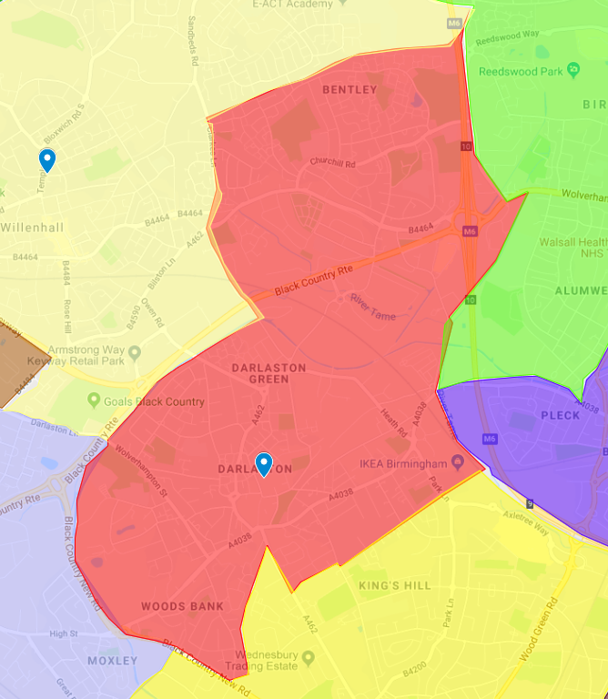

Official description of St Joseph’s parish boundary, Darlaston

Starting in the north-east at the junction of the Railway Line with Bentley Lane and Bloxwich Lane:
1. South along BLOXWICH LANE to its end on Wolverhampton Road;
2. East along WOLVERHAMPTON ROAD to its junction with the Stream near Primley Avenue (neither side);
3. South-west along the STREAM to its confluence with the River Tame near Bentley Mill Lane;
4. South along the RIVER TAME passing under Darlaston Road and continuing to its junction with the Railway Line;
5. Continuing south for a short distance along the RAILWAY LINE to a point opposite the junction of Franchise Street and Park Lane;
6. South-west in a STRAIGHT LINE to Franchise Street;
7. South-west along FRANCHISE STREET and its continuation SCHOOL STREET to the end on the Darlaston/Wednesbury Road (both sides);
8. North along DARLASTON ROAD for a short distance to the junction with the Railway Line (both sides);
9. South-west along the RAILWAY LINE to its junction with Woden Road;
10. West along WODEN ROAD NORTH to its junction with Holyhead Road (neither side);
11. North-west along HOLYHEAD ROAD to its junction with the Canal near Moxley Road (neither side);
12. North along the WALSALL CANAL to its junction with the Willenhall Road at Bughole Bridge;
13. North along the WILLENHALL ROAD and its continuations THE CRESCENT, CRESCENT ROAD and CLARKES LANE to the junction with the Railway Line near Slater Street (neither side);
14. East along the RAILWAY LINE to its junction with Bentley Lane and Bloxwich Lane.

Official description of the St Mary’s parish boundary, Willenhall.

Starting in the north-east at the junction of Sneyd Lane with the Wyrley and Essington Canal at Sneyd Lane Bridge:
1. South along the WYRLEY AND ESSINGTON CANAL to the Footpath at Bentley Wharf Bridge;
2. South along the FOOTPATH to Bentley Lane;
3. South-east along BENTLEY LANE and its continuation BLOXWICH LANE to the disused Railway Line;
4. West along the DISUSED RAILWAY LINE to Clarkes Lane;
5. South along CLARKES LANE and its continuations CRESCENT ROAD, THE CRESCENT and WILLENHALL ROAD to the Walsall Canal at Bughole Bridge (both sides);
6. South-west along the WALSALL CANAL to Darlaston Lane;
7. North-west along DARLASTON LANE to its end on Bilston Road (neither side);
8. North-east along BILSTON ROAD to its junction with the Keyway (neither side);
9. North-west along THE KEYWAY to its junction with Willenhall Road;
10. West along WILLENHALL ROAD to its junction with Neachell Lane (neither side); 11. North along NEACHELL LANE to the Bentley Canal (neither side);
12. East along the BENTLEY CANAL to Merrills Hall Lane;
13. North along MERRILLS HALL LANE to its end on Waddens Brook Lane (neither side);
14. East along WADDENS BROOK LANE to its junction with Broad Lane South (neither side);
15. North along BROAD LANE SOUTH and its continuation BROAD LANE NORTH to Lichfield Road (neither side);
16. East along LICHFIELD ROAD and its continuation SNEYD LANE to the Wyrley and Essington Canal at Sneyd Lane Bridge.

The former parish boundaries of Holy Trinity, Bilston and St Joseph’s, Wolverhampton

Other former parishes that make up the remainder of the new Newman parish. The former parish boundaries of St Joseph’s, Wolverhampton are in brown above The former parish boundaries of Holy Trinity, Bilston are in lilac, to the south of St Joseph’s parish The below image is for guidance purposes only.

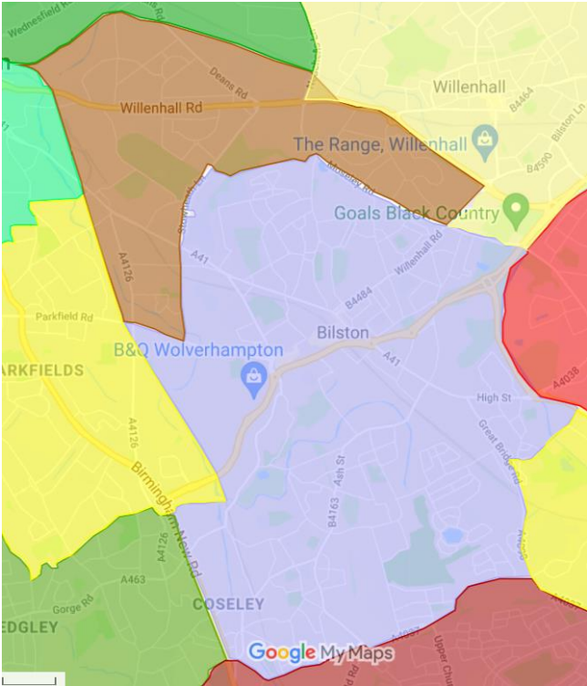

Official description of the former parish of Holy Trinity, Bilston.

Starting in the west at the junction of the Railway Line with Parkfield Road:
1. East along PARKFIELD ROAD and its continuation MILLFIELDS ROAD to Ward Street (both sides);
2. North along WARD STREET to its end on Wellington Road;
3. Continuing north across Wellington Road along STOWHEATH LANE to Warsash Close (neither side);
4. East along WARSASH CLOSE and PARK VIEW ROAD and continuing north of LAWNSIDE GREEN to Moseley Road (both sides and including all of Burlesden Walk); 5. South-east along MOSELEY ROAD to its end on Willenhall Road/Bilston Road (neither side);
6. Continuing south-east along DARLASTON LANE to the Walsall Canal (both sides); 7. South along the WALSALL CANAL to Holyhead Road;
8. East along HOLYHEAD ROAD (CHURCH STREET) to Bull Lane (both sides);
9. South-west along BULL LANE to Great Bridge Road (both sides, but excluding anything within the grounds of Moxley Hospital);
10. South along GREAT BRIDGE ROAD and its continuation BILSTON ROAD to Wednesbury Oak Road (both sides);
11. West along WEDNESBURY OAK ROAD and its continuation HIGH STREET to Bradleys Lane (both sides);
12. North-west for a short distance along BRADLEYS LANE to Fountain Lane (both sides);
13. West along FOUNTAIN LANE to Central Drive (both sides);
14. West along CENTRAL DRIVE to Birmingham New Road (both sides);
15. North along BIRMINGHAM NEW ROAD to Anchor Lane (both sides);
16. East along ANCHOR LANE to the Railway Line (neither side);
17. North along the RAILWAY LINE to its junction with Parkfield Road

Official description of the former parish of St Joseph’s, Wolverhampton.

Starting in the west where the Willenhall and Coseley Railway Lines divide just to the east of Wolverhampton Station:
1. East along the WILLENHALL RAILWAY LINE to Neachell Lane at Neachell Bridge;
2. South along NEACHELL LANE to Willenhall Road (both sides);
3. East along WILLENHALL ROAD to The Keyway (both sides);
4. South-east along THE KEYWAY to Bilston Road;
5. South along BILSTON ROAD to Moseley Road (both sides);
6. North-west along MOSELEY ROAD to Prouds Lane (both sides);
7. West across the north of LAWNSIDE GREEN and along PARK VIEW ROAD and WARSASHCLOSE to its end on Stowheath Lane (neither side, thus excluding all these roads and all of Burlesden Walk from the parish);
8. South along STOWHEATH LANE to Wellington Road (both sides);
9. Continuing south along WARD STREET to Millfields Road;
10. West along MILLFIELDS ROAD and for a short distance along PARKFIELD ROAD to the Railway Line from Coseley (neither side);
11. North along the RAILWAY LINE to its junction with the Railway Line from Willenhall to the east of Wolverhampton Station.

ST JOSEPH’S CATHOLIC PRIMARY SCHOOL
SUPPLEMENTARY INFORMATION FORM

If you are expressing a preference for a place for your child at St Joseph’s Catholic Primary School in Walsall and wish to apply under a criterion that requires additional evidence you should complete this Supplementary Information Form.

- The completed Supplementary Information Form, together with all supporting documentation (see Notes below), should be returned to Mr H Carroll, The Chair of Governs at the school by the closing date of 15th January 2028.
- If you are applying to more than one Catholic school you will need to complete a separate Supplementary Information Form for each school.
- If you do not provide the information required in this form and return it to the school, with all supporting documentation, by the closing date, your child may not be placed in the appropriate faith category and this may affect your child’s chance of being offered a place.
- Remember – you must also complete the Common Application Form.

Name of child: ______________________________________

Address of child: ______________________________________

______________________________________

______________________________________

Parent/Carer Name: ______________________________________

Parent/Carer Email: ______________________________________

Please read the school’s Admissions Policy, noting in particular any faith criteria, and your Local Authority booklet, before completing this form.

NOTE: When completing the Common Application Form, it is important that you provide details of any siblings (brothers or sisters) who will be attending the Catholic school at the proposed time of admission. If this information is not provided the admission authority of the Catholic school may not be able to place the application within the correct criteria.
Religious Status of child (please indicate by placing a tick in the appropriate box – please note that a tick should be indicated in only a single box)

 | Tick Box | Evidence: insert details in accordance with the Notes below
1. Baptised Catholic (see Note 1 below) | □
2. Catechumen (see Note 2 below) | □
3. Member of an Eastern Christian Church  (see Note 3 below) | □
4. Member of other Christian denomination  (see Note 4 below) | □
5. Member of other faith  (see Note 4 below) | □
If you have indicated above that your child is Catholic please confirm the parish in which your child lives:

In compliance with the UK General Data Protection Regulation (UK GDPR) and the Data Protection Act 2018, we wish to ensure that you are aware of the purpose for which we collect and process the data we have asked you to provide on this form.

- We are St Joseph’s Catholic Primary School, Rough Hay Road, Darlaston, Wednesbury, West Midlands. WS10 8HN

- Being a Catholic education provider, we work closely with the School’s Diocesan Authority, the School’s Trustees, the Local Authority, the Catholic Education Service and the Department for Education, and may share the information you provide on this application form if we consider it is necessary in order to fulfil our functions.
- The person responsible for data protection within our organisation is Mrs N Hannett and you can contact them with questions relating to our handling of the data. You can contact them by email: postbox@st-josephs.walsall.sch.uk
- We require the information we have requested for reasons relating to our functions as the admission authority of the school.
- It is necessary for us to process personal data for the performance of a task carried out in the public interest or in the exercise of official authority vested in the controller (Article 6(1)(e) of the UK GDPR).
- To the extent that you have shared any special categories of data this will not be shared with any third parties except as detailed in paragraph 2 above, unless a legal obligation should arise.
- It is necessary for us to process special category data for the performance of a task carried out in the public interest or in the exercise of official authority vested in the controller (Article 6(1)(e) of the UK GDPR). Additionally, processing is necessary for reasons of substantial public interest on the basis of domestic law which is proportionate to the aim pursued and which contains appropriate safeguards (Article 9(2)(g) of the UK GDPR).
- If the application is successful, the information you have provided on this form will be migrated to the school’s enrolment system, and the data will be retained and processed on the basis of the school’s fair processing notice and data protection policies which apply to that data.
- If the application is unsuccessful, the application form and any documents submitted in support of the application will be destroyed after a period of 12 months. The school may keep a simple record of all applications and their outcome as part of their permanent archives in accordance with the school’s data retention policy.
- To read about your individual rights you can refer to the school’s fair processing notice and data protection policies.
- If you wish to complain about how we have collected and processed the information you have provided on this form, you can make a complaint to our organisation following the processes set out in our Complaints policy: ARCHDIOCESE OF BIRMINGHAM. If you are unhappy with how your complaint has been handled, you can contact the Information Commissioner’s Office via their website at: ico.org.uk.
I confirm that I have read the Admissions Policy of the school and that the information I have provided is correct. I understand that I must notify the school immediately if there is any change to these details and that, should any information I have given prove to be inaccurate, the Admission Authority may withdraw any offer of a place even if the child has already started school.

Signed……………………….. Date………………………………

Supplementary Information Form Notes

1. Evidence of Catholic Baptism
If an application is being made for a place at the school for a Catholic child evidence of Catholic baptism or reception into the Church is required. A certificate of baptism or certificate of reception into the full communion of the Catholic Church should be provided at the same time as this form is returned to the school.
The school may request additional supporting evidence if the written documents that are provided do not clarify the fact that the child was baptised or received into the Catholic Church, e.g. where the name and address of the Church is not on the certificate or where the name of the Church does not state whether it is a Catholic Church or not. Those who have difficulty obtaining written evidence of baptism or reception into the Church should contact their Parish Priest.

2. Evidence for Catechumens
If an application is being made for a place at the school for a catechumen evidence of their being a member of the catechumenate of a Catholic Church will be required. A certificate of reception into the order of catechumens should be provided at the same time as this form is returned to the school.

3. Evidence of Membership of an Eastern Christian Church
If an application is being made for a place at the school for a member of an Eastern Christian Church, including Orthodox Churches, evidence of membership will be required. A certificate of baptism or reception from the authorities of that Church should be provided at the same time as this form is returned to the school.

4. Evidence for Other Christian Denominations and Other Faiths
If an application is being made for a place at the school as a member of another Christian denomination or another faith evidence confirming membership of that Christian denomination or faith, and signed by the appropriate minister of religion or faith leader, will be required. The evidence should be provided at the same time as this form is returned to the school.

Checklist:

Have you enclosed?
- Copy of baptism or certificate of reception into the Catholic Church (where applicable).
- Evidence confirming membership of a Christian denomination or other faith (where applicable).
Have you completed and returned your local authority’s Common Application Form?

This is for admission to the school at the start of the school year in September and not for applications made in-year.
This is for admission to the school at the start of the school year in September and not for applications made in-year.

