
Key vocabulary
Multiply- Adding equal groups a certain number of times, e.g. 5 x 4 = 5+5+5+5 = 20.
Can also be referred to as groups of or
lots of.
Divide- Sharing or grouping numbers/objects into equal groups, e.g. 10
÷ 5 = 2.
Questions to ask at home
What is 10 multiplied by 8?
What is 10 times 3?
What is 100 divided by 10?
How many groups of 10 can you make from 20 objects?
Things to try
Beat the clock- You have 10 seconds to answers as many questions as you can. Each correct answer will earn you one second of extra time. The game ends when the time runs out or an incorrect answer is given.
Multiplication race– Write the answers to the 10 times table (10, 20, 30 etc.) n large pieces of card. Shout out a random 10 times table question and race your child to the right answer.
10p challenge– Gather some 10p coins, how many pence is there in total? What would this be as a multiplication sum? Change the number of coins and repeat.
Websites: White Rose video: Spr2.2.5 - 10 times-table on Vimeo
Whack A Mole || Counting in steps of 1, 2, 3 12 (ictgames.com) Duck Shoot - tablet friendly (ictgames.com)
Year Two – Spring 2
KIRF: I know the 10 times table (x and ÷)
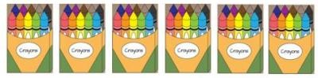
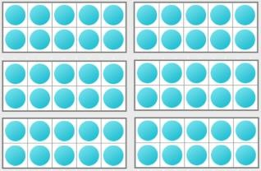
The ten times table is a key skill for KS1 learners. They should already be able to count forward and backwards in 10’s, now they need to apply that be able to multiplication facts. They should be able to answer these questions in any order, including missing number questions, e.g. _ x 10 = 80.
Concrete:
What can this look like?
Pictorial:
Abstract
6 multiplied by 10 = 60
6 x 10 = 60
60 = 10 x 6
60 divided by 10 = 6
60 ÷ 10 = 6

