Key vocabulary
12 add 8 equals 20
18 plus 2 is the same as 20
20 take away 7 equals 13
20 subtract 3 makes 17
20 minus 9 equals 11
Questions to ask at home
What do we need to add to 13 to make 20?
If I have 10, how many more do I need to get to 20?
What is the difference between 20 and 12?
Activity Ideas
Chants- Practice chanting the number bonds.
Paper Chains- Use two different colours to make paper chains to show each number bond, for example 14 + 6 could be shown as 14 green links and 6 blue links.
Say it, make it, write it- For each number bond, say it our loud, make it using everyday objects and then write it as a sum.
Pegs – Put 20 pegs on to a coat hanger, split them in different ways and count how many pegs are on each side. E.g. 14 pegs + 6 pegs = 20 pegs (14+6=10).
Websites: White Rose video: Aut2.5.1 - Fact Families on Vimeo
Funk Mummy || Quick recall of addition, subtraction and multiplication facts || Mobile- friendly version (ictgames.com)
Smoothie Maths || Practise number facts to 10, then 20 (ictgames.com)
Year Two – Autumn 1
KIRF: I know number bonds to 20
Number bonds show us how numbers join together. They are very important for addition and subtraction. This half term, the children will be learning number bonds that make 20; they should be able to recall these independently.
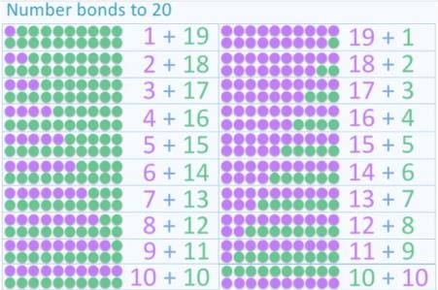
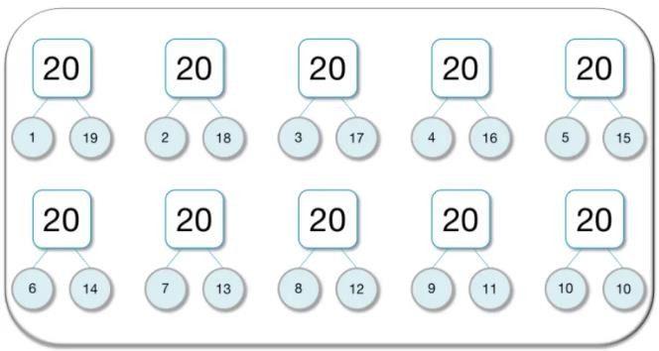
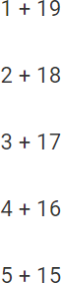
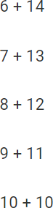
Concrete:
What can this look like?
Pictorial:
Abstract:

