
Key vocabulary
Minute hand – the longer hand.
Hour hand – the shorter hand.
Half past – 30 minutes past the hour.
O’clock – on the hour
Quarter past – 15 minutes past the hour.
Quarter to – 45 minutes past the hour
past e.g. five past one to
e.g. ten to five
Questions to ask at home
Where does the minute hand point when it is 20 past?
Which side of the clock will the minute hand be if it is a ‘past’ time? Or a ‘to’ time?
Things to try
What time is it?- Find as many opportunities as possible to ask your child what time it is throughout the day. This will also help them to understand what happens at different times.
Hula hoop clock- Use a hula hoop, chalk for the numbers and some sticks to make your own clock.
Time monitoring- Give your child responsibility for keeping track of the time, for example ‘We need to take the cakes out of the oven at 5 past 2. Tell me when that is.’

Websites: https://mathsframe.co.uk/en/resources/resource/116/telling_the_time# https://www.sheppardsoftware.com/math/time/clock-splat-game/
Year Two – Summer 2

Children need to be able to tell the time using a clock with hands (analogue clock). They should already be able to read o’clock, half past and quarter to/past.
KIRF: I can tell the time to the nearest 5 minutes.
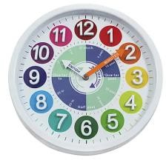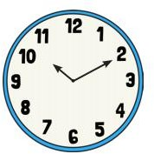
Concrete:
What can this look like?
Pictorial:
Abstract:
10 minutes past 10.
Ten past 10.

