
Talk about time
Discuss what time things happen. Try to make sure an analogue clock is visible at home or the child can use a watch throughout the day.
Questions to ask at home
What hour is it?
Where does the minute hand point to when it is quarter past the hour?
What time is it now?
What would an analogue clock look like in 6 minutes time?
Key vocabulary
The time is 12 o’clock
It is half past two It is quarter to five
It is twelve minutes past one
It is thirty six minutes past four.
Year Three – Summer 2
KIRF: I can tell the time to the nearest minute
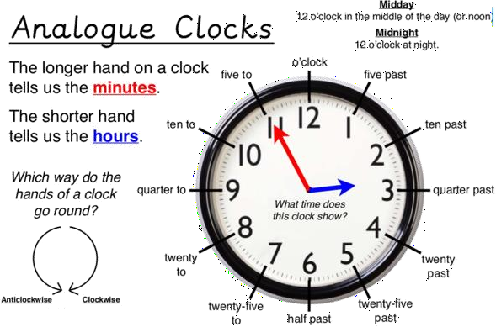
This half term, the children will be learning how to tell the time on an analogue clock (a clock with hands) to the nearest minute. The aim is for them to be able to read the time instantly.
Things to try

Websites –
https://mathsframe.co.uk/en/resources/resource/116/telling-the-time Use this website for an interactive telling the time game.
A watch- Practice is important with telling the time and a watch is an easy was to practice those newly learnt skills.
Breaking it down
Children need to be able to tell the time using a clock with hands. This target can be broken into several steps:
- I can tell the time to the nearest hour.
- I can tell the time to the nearest half hour.
- I can tell the time to the nearest quarter hour.
- I can tell the time to the nearest 5 minutes.
- I can tell the time to the nearest minute.

