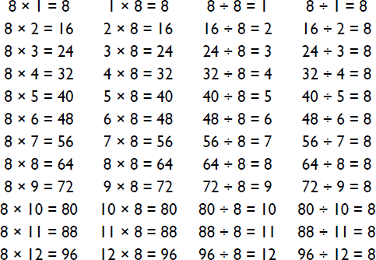

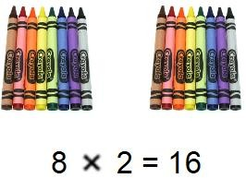
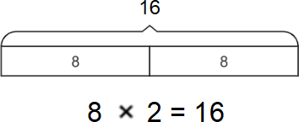
Things to challenge
If your child becomes confident with these multiplications try them with missing number questions e.g.
8 ×
= 24 or
÷ 8 = 7
Concrete:
What can this look like? –
Pictorial:
Abstract:
Year Three – Spring 2
KIRF: I know the 8 times table (× and ÷)
A times table is a list of multiples of the given number. They are very important for many calculations. This half term, the children will be learning their 8 times tables including the division facts.
.
Questions to ask at home
What is 8 multiplied by 7?
What is 9 times 8?
What is 32 divided by 8?
Key vocabulary
8 multiplied by 3 is equal to 24
2 times 8 and 8 times 2 are equivalent
32 shared by 4 is equal to 8
40 divided by 8 equals 5
Things to try
Chants- Practice chanting the times table.
Double your 4’s – Multiplying a number by 8 is like multiplying by 4 and then doubling. 8×4=32 so double 32=64, therefore 8×8=64
Five Six Seven Eight – fifty six is seven times eight (56=7×8)
Websites:
https://ttrockstars.com/ - Ask your teacher to set your TT Rockstar account to focus on the 8’s.
https://www.topmarks.co.uk/maths-games/hit-the-button

