.
Year Three – Spring 1
KIRF: I know the 4 times table (× and ÷)


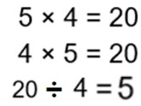
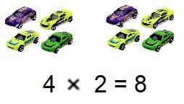
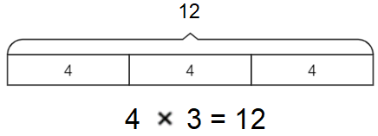
Concrete:
What could this look like?
Pictorial:
Abstract:
Things to challenge
If your child becomes confident with these multiplications try them with missing number questions e.g.
4 ×
= 24 or
÷ 4 = 11
A times table is a list of multiples of the given number. They are very important for many calculations. This half term, the children will be learning their 4 times tables including the division facts.
Key vocabulary
4 multiplied by 6 is equal to 24
2 times 4 and 4 times 2 are equivalent
24 shared by 6 is equal to 4
40 divided by 4 equals 10
Questions to ask at home
What is 4 multiplied by 7?
What is 12 times 4?
What is 32 divided by 4?

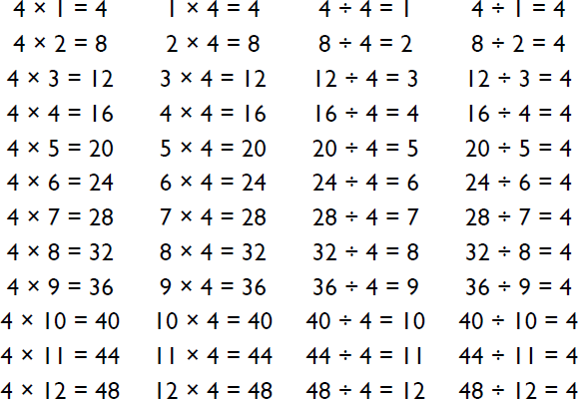
Things to try
Chants- Practice chanting the times table.
Everyday Objects- Gather together objects and separate them into groups of 4.
Double & Double again – Multiplying by 4 is the same as doubling and doubling again. Double 6 is 12 and double 12 is 24, so 6 × 4 = 24.
Websites:
https://ttrockstars.com/ - Ask your teacher to set your TT Rockstar account to focus on the 4’s.
https://www.topmarks.co.uk/maths-games/hit-the-button https://www.timestables.co.uk/

