
Year 3 Curriculum Overview for Parents Spring 1 2026
What will your child be learning this half term?

Whole class reading –  We will use the classic Roald Dahl tale ‘Charlie and the Chocolate Factory’ to help us work on developing our comprehension skills by focusing on Vocabulary, Inference, Prediction, Explanation and Summarising. | Religious Education (R.E.) –  – At the start of this half term, we will be looking at the season of Christmas in the Church calendar and the key people involved during the Nativity story. We will give particular focus to the shepherds and their experiences of Jesus’ birth as well as the impact that had upon them. Finally, we will consider the importance of the crib which helps us to remember Jesus’ continued presence in our world.  We continue our faith journey when we begin learning about the Mass and the Liturgy of the Word. Within these lessons, the children will explore more Bible stories and the relevance these continue to have upon us today. We end this unit of work by exploring the importance of attending Mass, the reasons to attend Mass and what we can achieve by listening to the Word of God.  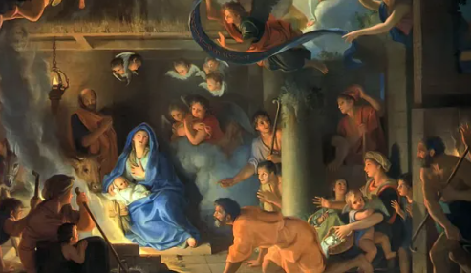
The focus book for our writing this half term will be The Egyptian Cinderella where we will be looking at using the information from the text about Greece and Egypt to create a setting description about Egypt in our learning and develop our skills to create our hot write to use the correct tense, expanded noun phrases to describe, co-ordinating conjunctions (and, but, or, so), subordinating conjunctions (when, if, because), emotional language; use of feelings, sensory description.  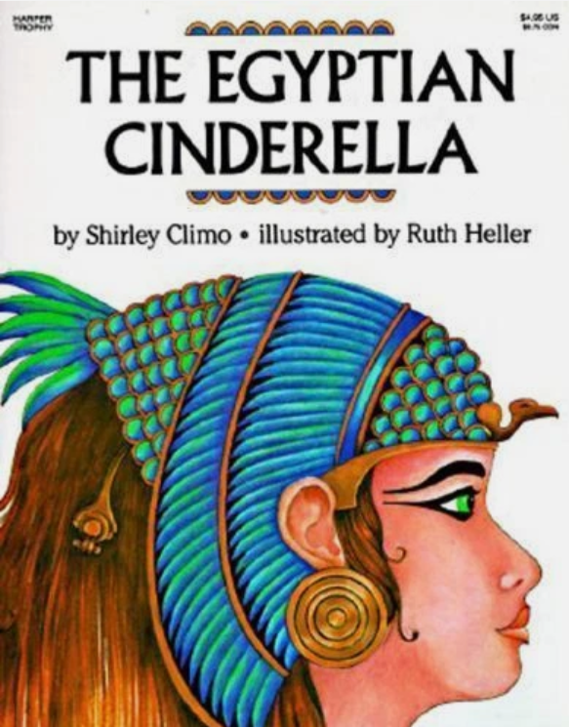  In our second text of the half term, we will use the classic tale of The Iron Man by Ted Hughes to retell the story from Iron Man’s perspective using correct writing structure, adverbs, prepositions, inverted commas, expanded noun phrase, prefixes, descriptive language. For our hot write, we will use our knowledge to create a retell from the point of view of the man character Hogarth.  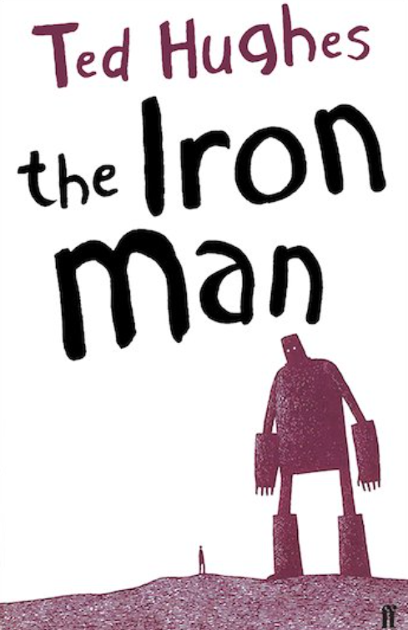 | Maths –  This half term the children will look at the following mathematical topics; mass and capacity, right angles, developing strategies in adding and subtraction number. This will include partitioning and unitising to aid their understanding of mental calculations.  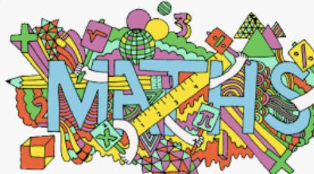
Our grammar focus will be –  During the first half term, we will focus on the basics of quality and engaging written work, these are nouns, verbs, adjectives, capital letters and full stops, conjunctions and sentence starters. More specifically to our writing topic, writing in paragraphs, correct use of tense, using conjunctions, prepositions, fronted adverbials, use inverted commas for speech | Mental Maths -  This half term we will continue looking at:  - continuing counting backwards from a number.  - continue our understanding of multiplication and division facts linked to the 3, 4 and 8 times tables.  - fluently knowing number bonds to 10 and to 20  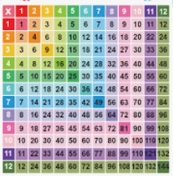
History  In History, we will be completing our topic from Autumn 1 on Pre-Historic Britain. This will include looking in more detail at Stone Age settlements and developing a greater understanding of the era as these people developed.  - The first use of bronze.  - How bronze changed life in Britain.  - The beginning of the Iron Age.  - Changing agriculture in Britain during the Iron Age.  - Changing settlements and trade in Iron Age Britain.  - Comparing and contrasting Bronze Age and Iron Age Britain.  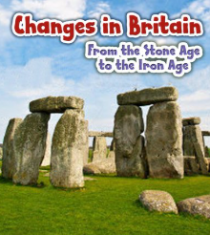 | Science –  This half term we will be learning about the human body, focussing on the skeleton – its job to protect and support us. We will explore the make-up of the human skeleton and different bones within it. We will also look at muscles and how they work to allow us to move and support our bodies to do what we need it to do.  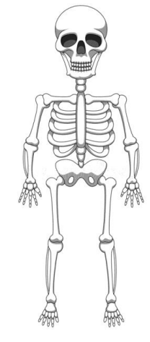
Physical Education (P.E.)  This half term the children will have PE on Mondays and Tuesdays. Children will need kit both days to participate in lessons with Mr Davies.  This half term the children will be participating in dance and dodgeball. These will help the children to develop skills in both individual disciplines as well as being part of a team.  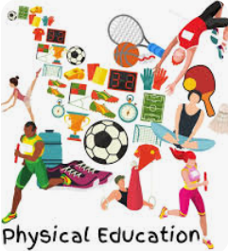 | French –  During this half term the children will learn to recognize and to use vocabulary relating to clothing. They will learn to apply their understanding of noun and adjective agreement in French. They will create their own outfit and describe in French.
Personal, Social & Health Education (PSHE) – In this unit of work in PSHE, we will be learning about positive health (both mental, physical and emotional). We will deepen this learning by exploring the consequences of these behaviours as well as how we can improve our reaction to different situations.  Linked to our physical health, we will receive a visit from the school nurse and partake in a workshop involving the need for a good diet, healthy eating and having a positive self-image.  Finally, we will be exploring how the pressures of the modern world can affect our idea of right and wrong, appropriate and inappropriate behaviours. | Art –  In our Art lessons the children will be exploring shape and colour. We will be cutting directly onto paper to explore shapes in our art, use stencils and add to our work creating a collage.
Computing –  The children will develop their understanding and use branching databases. In this unit, children will look at how databases can be constructed and use this learning to identifying hat branching databases can be used for.   | Music –  This half term in Music, the children will be looking at the history of music, relative to the pieces played in the class. Rock and Roll from the 1950s; shake, rattle and roll etc. We will look at iconic rock n roll artist Elvis Presley as well as explore music in America in the 1950s.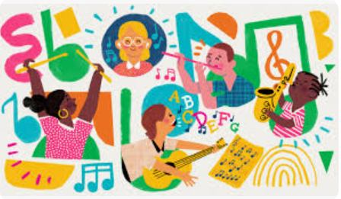

Additional important information
- Monday 5th January – school closed for children
- Tuesday 6th January – school reopens for all children
- Thursday 15th January – parent workshop for Maths lesson – looking forward to seeing you all!
- Wednesday 21st January – ‘Pep’ the Poet workshops
- Saturday 24th January – Parish Mass at St Joseph’s Darlaston looking forward to seeing you all!
- Tuesday 27th January – Year 3 to Parish Mass at 10am
- Thursday 12th February – Severn Trent Water workshop

Homework in Year 3
• Children are expected to read every day for 15 - 20 minutes – please sign your child’s planner and feel free to add a comment after completing this reading time together.
• Mental Maths – we will be focussing on our 2, 3, 4, 5, 8 and 10x tables, as well as working on counting backwards from a number.
If you have any questions or concerns, please speak to me at the end of the school day or contact the school office to make an appointment.
Mr Black and Mrs Rasool

