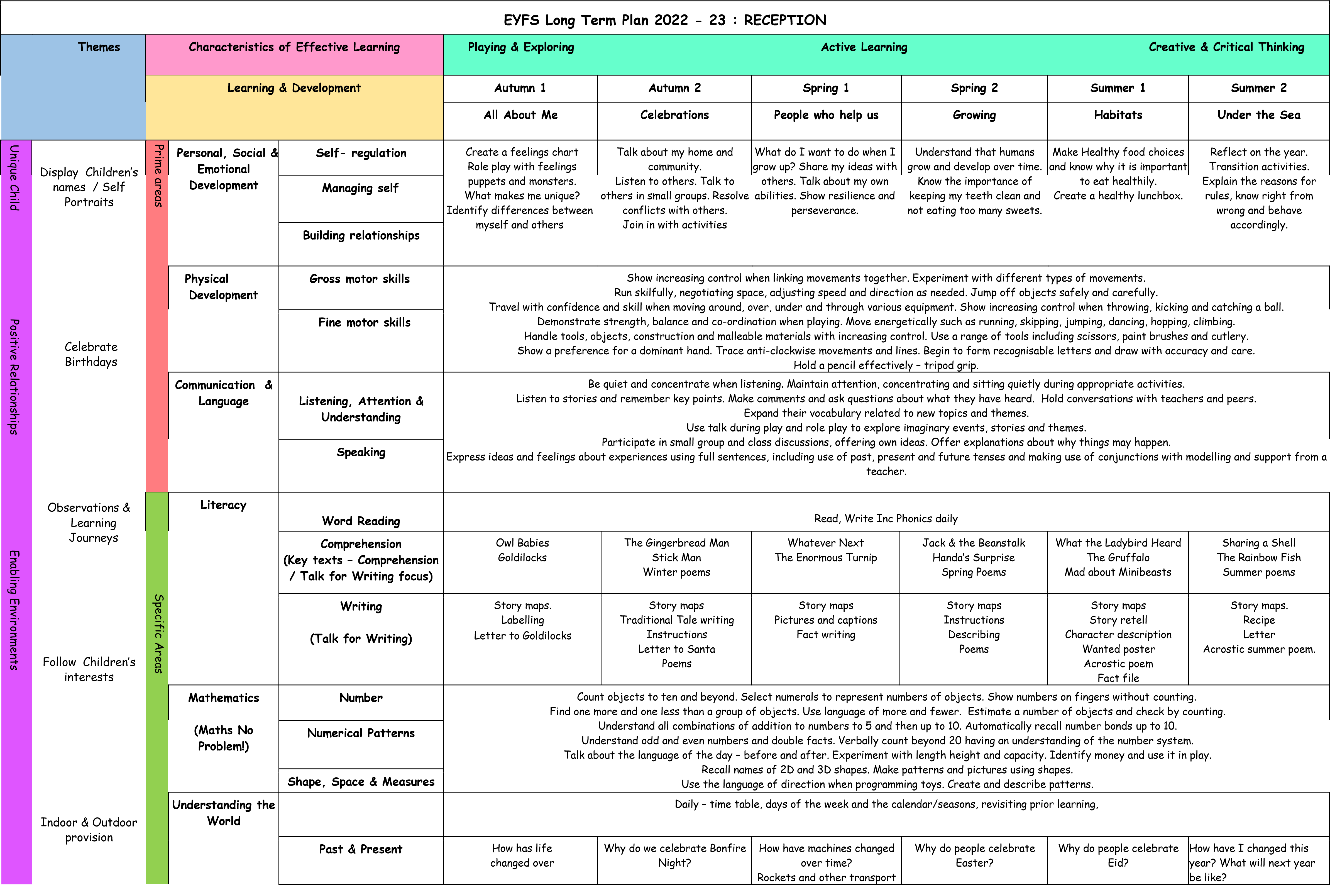

 | Support &  Scaffold learning for all Children  Grouping Children to support skills/ needs |  |  |  | time for my family?  Time lines of our life, school day, year ect. | Why do people celebrate Diwali?  Why do we celebrate birthdays?  Why do people celebrate Christmas? | Compare aeroplanes and trains past and present | How have we changed? Time lapse video of growing baby, our own baby photos – guess who game. |  | Changes to the planet – climate/ litter etc.
 |  |  |  | People, Culture & Communities | Understand my family is unique.  Community mapping.  Favourite places in my community.  Where do we live?  Our school maps | How do we celebrate Bonfire  Night? How do people celebrate Diwali? How do  celebrate birthdays? How do  people celebrate Christmas in  the UK and other countries?  How have Christmas celebrations changed over time? | What does a doctor do?  Where do doctors and nurses  work? What do police officers do?  What do firefighters do?  What does an engineer do?  Why do people use trains?  Find a train station on a map. | How do people celebrate  Easter in the UK and other countries? | How do people celebrate Eid?  Key features of a mosque. | Inviting my family to attend end of year school activities  e.g., sports day.
 |  |  |  | The Natural World | Gather natural objects to create a face picture.  Explain changes around me in Autumn.  Gather natural objects to create a collage. | Hot & cold experiment  Hot and Cold places – what do people need?  Winter walk | How is the the natural world changing around me? Notice changes in seasons –  environment, growth, decay, living things, weather. | Life cycles  Animals and their babies.  What do animals need to grow?  What do animals need to grow?  Plant seeds and sequence stages of plant growth Changes in spring.  Observation of the parts of a flower.  Fruit and Vegetables | What is a habitat?  Match animals to their habitats. Minibeast safari.  Rainforest and rainforest animals.  Polar habitat – locate on a globe .Polar animals.  Impact of cutting down trees – effect on  rainforest habitat.  Global warming – effect on polar habitat.  Melting ice experiment. | Identify changes – features of summer.  How do trees change in the seasons? Creatures that live under the sea.  Features of an underwater cave. What might I see at the beach? Rock pool creatures. Floating &  Sinking. Why do oceans become polluted? Features of the solar system
 |  |  | Expressive Arts & Design | Creating with Materials | Create an all about me box.  Create a face using natural materials. Build my home.  Create a family photo & collage. Paperchain people.  Create feelings puppets and monsters. Self-portraits.  Create a model of myself. Mix colours to create an Autumn  painting | Chalk firework pictures Bonfire collage Create firework model. Mendhi patterns Maker a birthday card.  Create a Menorah  Create a star and Nativity scene.  Christmas card & decorations | Build a hospital (junk modelling)  Paint picture of a fire-engine  Create a fire-engine – construction.  Create bridges.  Design a mode of transport.  Construct a vehicle.  Make a shape vehicle. | Build a bed for a teddy bear.  Chick potato prints.  Seed & Bean mosaic.  Take photographs of objects in Spring.  Observational drawing – flowers.  Vegetable faces.  Make a fruit salad.  Easter cards. | Shoebox habitats.  Printing – animal tracks.  Construct a minibeast model. Create a bug hotel.  Create a rainforest.  Rainforest animal masks.  Eid decoration & celebration picture. Build an igloo.  Finger painting – cold habitat. Paper snowflakes.  Recycled art. | Seasons collage. Make a flower. Ocean sensory  bottles. Junk model sea creatures. Build an  underwater cave. Make sunglasses. Make a  rockpool. Build a boat that floats. Ocean playdough.  Plastic collage Draw the planets  Space vehicles. Build a rocket or spaceship.
 |  |  |  | Being Imaginative and Expressive | Make something for a friend.  Make something for someone in my community.  Home corner role play | Decorate a birthday cake.  Explore hot and cold colours.  Decorate Gingerbread cookies. | Role play (job roles)  Design and create a new invention  Role play train journey Design your own map. | Role play – caring for a baby.  Create an Easter egg hunt map. | Animal role play  Pentecost-movement and music | What could an alien look like?
Religious Education  ( Learning and Growing as the people of God) |  |  |  |  | Creation  People who care for us | Prayer Advent | Christmas  Baptism | Lent Holy Week | Easter Pentecost | People who help us  Continuous Prayer
Key Texts  (Linked to Understanding the World & Expressive Arts & Design) |  |  |  |  | It’s My Birthday (O.A)  More People to Love me – Mo  O’Hara  The Lion & The Mouse  A Hat for Mr. Mountain-  Soojin Kwak  Teim’s First Day (OA)  Chocolate Milk Por Favor-  Maria Dismondy  Nog’s First Autumn (OA) | The Gunpowder plot  The story of Diwali  Blwyd’s Birthday (OA)  Snowball – Sue Hendra  O Christmas Tree – Sue  Hendra  Nativity Story | Sal is sick (OA)  Hedd saves the day (OA)  The dream team (OA)  Vera Jewel is late for school –  Nicola Kent  Wow Vehicles, a book of extraordinary facts.  The hundred decker bus – Mike Smith | Lulu reads to Zeki – Rosalind  Beardshaw  The Enormous Turnip  Haul’s Sunflower (OA)  What a mix up! (OA)  I don’t like vegetables (OA) Easter story | Tidy – Emily Gravett  Hoot Owl, Master of  Disguise – Sean Taylor  Little Monkey – Marta Altes  Fatima’s Ramadan (OA)  Where snowflakes fall -  Claire Freedman  Greta & the Giants – Zoe Tucker | I’m bored –(OA)  Fidgety Fish – Ruth  Galloway  Sally & the limpet – Simon  James  Brilliant Boats – Tony  Mitten  Polly Plastic (OA)  How to Catch a Star –  Oliver Jeffers
Cultural Capital |  |  |  |  | Harvest Festival Nurse visit | EYFS Nativity. Santa Safari Trip | Visits from Doctors, nurses, police, firefighters, | Easter bonnet parade | Bug hotel making Minibeast hunt outside | Sea Life Centre Visit Sports Day
 | Owl Visit Care home visit | Fireworks safety speaker  Diwali speaker  Festivals workshop | Vintage car to school | Visit to farm / farm on wheels.  Chick hatching project- GC  Butterflies to caterpillars | Habitat workshop | Park visit Sun safety speaker

